Defining the Sketch of the Solving Methodology

**Topic:** Research on Chest X-rays to deduct various respiratory infections

**Methodology to reduce the noise our the X-ray Images**

In an chest X-ray test where only a small amount of radiation has been used to create the image (low exposure), the distracting visual appearance of the statistical noise sometimes known as “salt and pepper” noise relative to the size of the signal variations generated by the patient’s anatomy, can reduce the visibility of subtle, clinically important features.

To reduce salt and pepper and other noise we have so many filters to reduce but in those filters I am going to test with different filters, so that we can have scope to tune image without any noise on it. Main important filter we normally use for chest x-ray was median filter because Median filtering is very widely used in digital image processing because under certain conditions, it preserves edges whilst removing noise. The main idea of the median filter is to run through the signal entry by entry, replacing each entry with the median of neighbouring entries. Median filters are widely used as smoothers for image processing, as well as in signal processing and time series processing. A major advantage of the median filter over linear filters is that the median filter can eliminate the effect of input noise values with extremely large magnitudes.

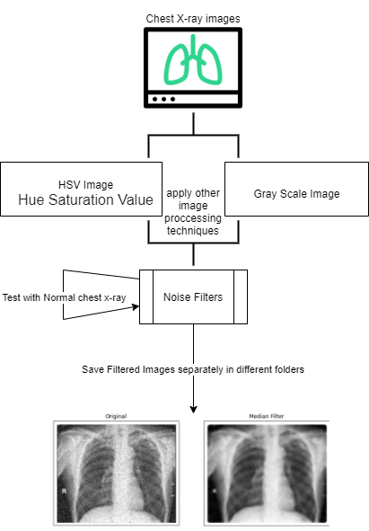

**Methodology to detect the covid-19 severity in Chest X-rays**

After taking chest x-ray dataset I am going to build a model to detect whether it is normal or effected by COVID-19 once the confirmation I will give to the other model to check the severity of the disease for example negative and positive case x-rays if we take based on the disease the model will identify if its positive case it will define the severity of that disease inside other model. Here severity can be taken from RALO (Radiographic Assessment of Lung Opacity) dataset in which Radiological scoring was performed by three blinded experts: two chest radiologists (each with at least 20 years of experience) and a radiology resident. They staged disease severity using a score system, based on two types of scores (parameters): extent of lung involvement and degree of opacity.

Extent of lung:

0 = no involvement

1 = <25% involvement

2 = 25%-50% involvement

3 = 50%-75% involvement

4 = >75% involvement.

Degree of Opacity:

0 = no opacity

1 = ground glass opacity

2 = consolidation

3 = mix of consolidation and ground glass opacity (>50% consolidation)

4 = white-out

The total opacity score ranged from 0 to 8 (right lung and left lung together).

**Methodology to detect the Pneumonia in Chest X-rays**

Pneumonia is an infection that causes inflammation in one or both of the lungs. An x-ray exam will allow your doctor to see your lungs, heart and blood vessels to help determine if you have pneumonia. When interpreting the x-ray, the radiologist will look for white spots in the lungs (called infiltrates) that identify an infection. I am going to build the deep learning model to identify whether the given chest x-ray has pneumonia or not.

I have to implement one deep learning model to detect whether the x-ray consists of pneumonia or covid-19. Apart from this model should return the accuracy and the table with count of x-rays having covid-19 and pneumonia that means for example in a given input it will show as X images has affected by pneumonia and Y images are affected by Covid-19 remaining images are neutral or normal without these two diseases.

